Name: G R Aakaash Slot: A
Reg No: 192412068 Course faculty: Sathish,K

EXP-6 5G NR Frame Structure Analysis with Different Subcarrier Spacing

Objective-1: To analyze different Subcarrier Spacing (SCS) values used in 5G NR numerology.
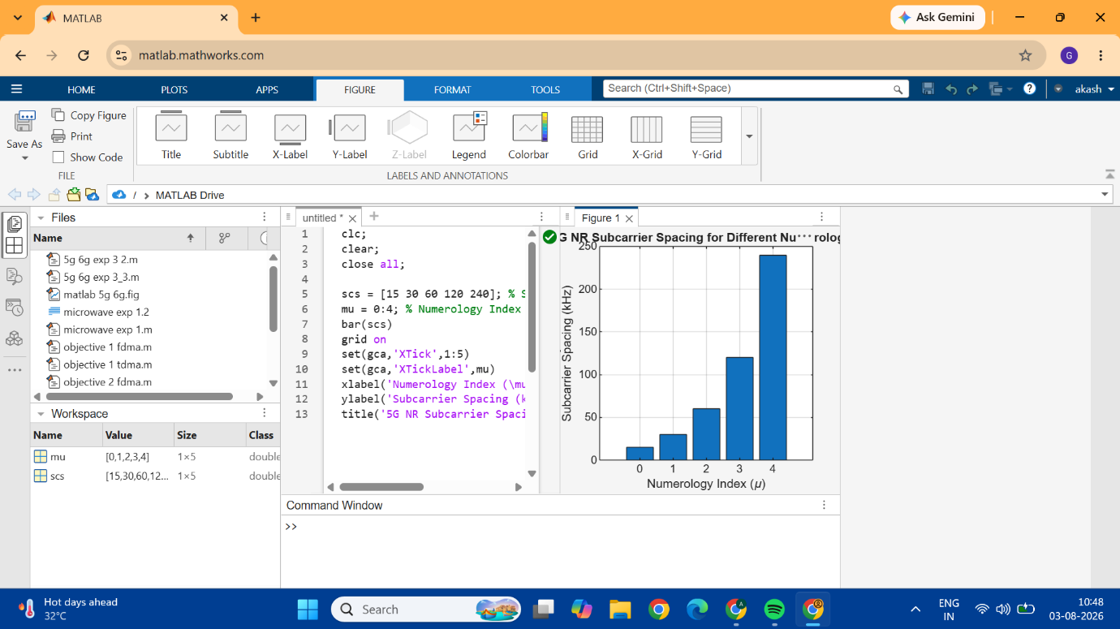
CODE:
clc;
clear;
close all;

scs = [15 30 60 120 240]; % Subcarrier Spacing (kHz)
mu = 0:4; % Numerology Index
bar(scs)
grid on
set(gca,'XTick',1:5)
set(gca,'XTickLabel',mu)
xlabel('Numerology Index (\mu)')
ylabel('Subcarrier Spacing (kHz)')
title('5G NR Subcarrier Spacing for Different Numerologies')
Objective-2: To compare the slot duration corresponding to different Subcarrier Spacing values in 5G NR.
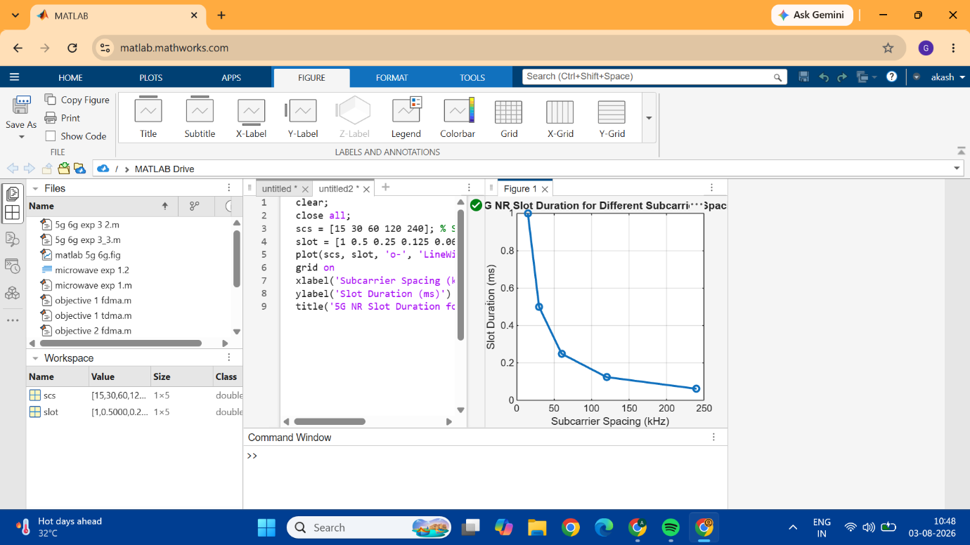
CODE:
clear;
close all;
scs = [15 30 60 120 240]; % Subcarrier Spacing (kHz)
slot = [1 0.5 0.25 0.125 0.0625]; % Slot Duration (ms)
plot(scs, slot, 'o-', 'LineWidth', 2)
grid on
xlabel('Subcarrier Spacing (kHz)')
ylabel('Slot Duration (ms)')
title('5G NR Slot Duration for Different Subcarrier Spacing')

Obejective-3: To study the number of OFDM symbols present in a 5G NR slot for normal cyclic prefix.
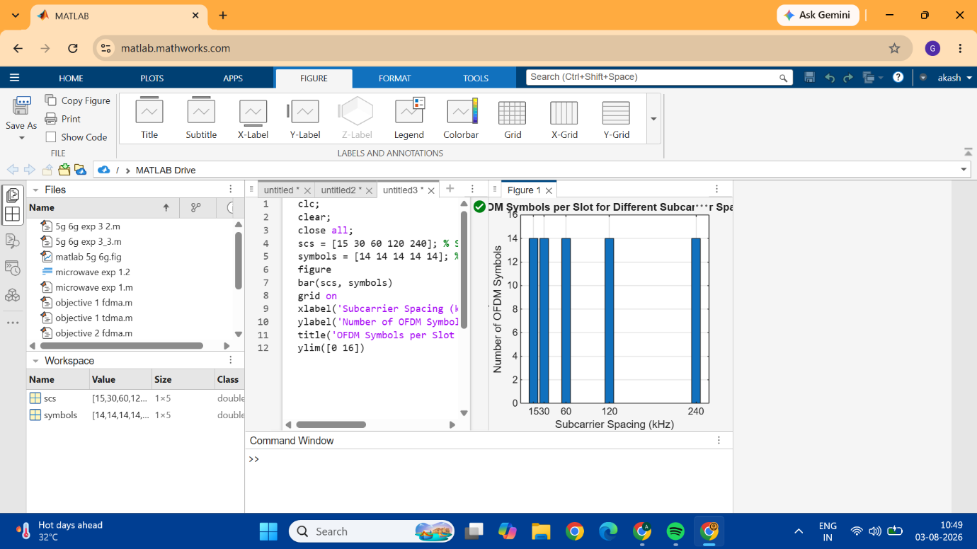
Code: \
clc;
clear;
close all;
scs = [15 30 60 120 240]; % Subcarrier Spacing (kHz)
symbols = [14 14 14 14 14]; % OFDM Symbols per Slot
figure
bar(scs, symbols)
grid on
xlabel('Subcarrier Spacing (kHz)')
ylabel('Number of OFDM Symbols')
title('OFDM Symbols per Slot for Different Subcarrier Spacing')
ylim([0 16])

